Layered Architecture

# Key concept

* Request moves from layer to layer (closed)
* Concept: layer of isolation
  + Not tightly coupled
  + No interdependencies
  + 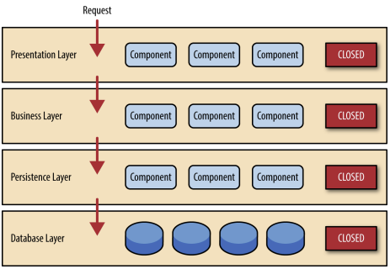Each layer is independent to another

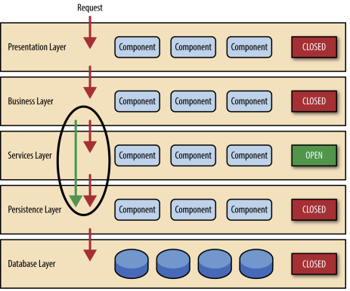Open Layers:

High: Testability, Ease of development

Low: overall agility, ease of deployment, Performance, Scalability